***Reverse an Array***

Given an array (or string), the task is to reverse the array/string.  
**Examples :** 

Input : arr[] = {1, 2, 3}

Output : arr[] = {3, 2, 1}

Input : arr[] = {4, 5, 1, 2}

Output : arr[] = {2, 1, 5, 4}

**Iterative way :**

*1) Initialize start and end indexes as start = 0, end = n-1*  
*2) In a loop, swap arr[start] with arr[end] and change start and end as follows :*  
*start = start +1, end = end – 1*

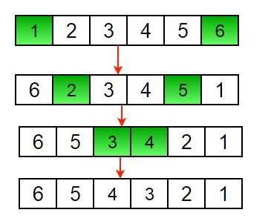

Another example to reverse a string:

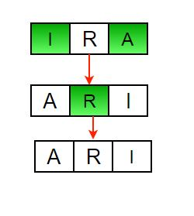

Below is the implementation of the above approach :

C++Java

// Iterative java program to reverse an

// array

public class GFG {

/* Function to reverse arr[] from

start to end*/

static void rvereseArray(int arr[],

int start, int end)

{

int temp;

while (start < end)

{

temp = arr[start];

arr[start] = arr[end];

arr[end] = temp;

start++;

end--;

}

}

/* Utility that prints out an

array on a line */

static void printArray(int arr[],

int size)

{

for (int i = 0; i < size; i++)

System.out.print(arr[i] + " ");

System.out.println();

}

// Driver code

public static void main(String args[]) {

int arr[] = {1, 2, 3, 4, 5, 6};

printArray(arr, 6);

rvereseArray(arr, 0, 5);

System.out.print("Reversed array is \n");

printArray(arr, 6);

}

}

**Output :**

1 2 3 4 5 6

Reversed array is

6 5 4 3 2 1

**Time Complexity :** O(n)